EXPERIMENT 1
SHOBBIKA T 240701502

COMPARISON OF UI DESIGN BETWEEN TWO FIGMA CREATION.

BAD DESIGN :

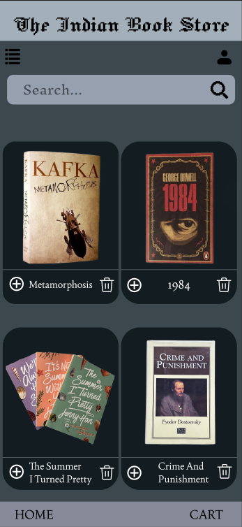

1. Design Style
- Uses a dark theme with book cards displayed in a grid layout.
- The layout is simple and consistent, but it does not include visual grouping or category sections.
- All books appear in one list, which makes the interface look uniform but less informative and more spacious.

2. Content
- Each book card contains:
  - Book image
  - Book title
  - Add (+) icon
  - Delete (trash) icon
- However, the design does not provide genre or category information, so users cannot easily identify the type of books.

3. Navigation
- Includes:
  - A hamburger menu icon
  - A search bar
  - Home and Cart buttons at the bottom
- Navigation options are basic and allow users to search or move between main pages, but there are no quick shortcuts to browse book categories.

4. Usability
- Users can browse and add books to the cart easily using the add (+) button.
- However, since books are not grouped into categories, users must manually scan the entire list to find specific types of books.
- This can slightly increase the time required to locate a particular genre.

5. Purpose
- Focuses mainly on displaying books for selection and purchase.
- The interface prioritizes product display and basic shopping actions.

GOOD DESIGN :
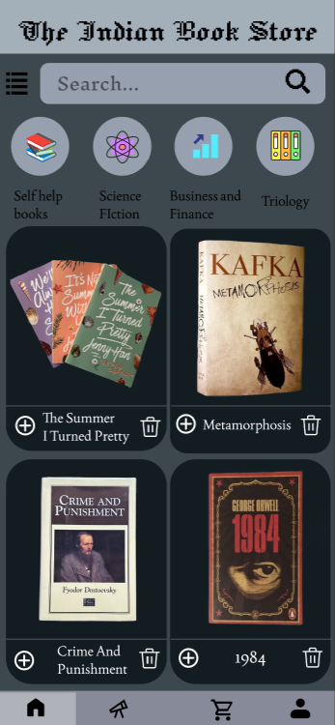

1. Design Style
- Maintains a similar dark theme but introduces additional visual elements for better organization.
- Includes category icons with labels, creating a clearer browsing structure.
- The layout looks more informative while keeping the same book card design.

2. Content
- Displays the same books as the first design.
- Adds category sections such as:
  - Self Help Books
  - Science Fiction
  - Business and Finance
  - Trilogy
- These categories help users understand and filter available books more easily.

3. Navigation
- Navigation is expanded with:
  - Bottom navigation icons (Home, Explore, Cart, Profile)
  - Category shortcuts
  - A search bar for direct searching
- This allows users to navigate through the app in multiple ways.

4. Usability
- Category icons provide faster browsing for users looking for specific genres.
- The interface supports both:
  - search-based discovery
  - category-based exploration
- This improves the overall browsing experience.

5. Purpose
- Designed to support both product browsing and category-based exploration.
- The interface helps users find books faster by organizing content into genres.

Key Differences :
- Content Organization: The first design lists books without categories, while the second introduces genre-based categories.
- Navigation Options: The second interface provides additional navigation elements like category icons and more bottom navigation options.
- Browsing Experience: Users can discover books more easily in the second design due to the presence of categories.
- Information Clarity: The second design provides more context about the books through genre labels.
- User Interaction: The improved navigation in the second design supports quicker exploration and easier access to different sections.

Prototype Link: https://www.figma.com/design/wQzsGhiqEcT0kjNhwka7lz/UID-exp-1-bad-design-?t=Mr0Uyae86oXtqO5l-1

